ASSIGNMENT – 2

|  |  |
| --- | --- |
| Assignment Date | 28 September 2022 |
| Student Name | R. Kowshalya |
| Student Roll Number | 511319106021 |
| Maximum Marks | 2 Marks |

**QUESTION**

Build a python code, Assume you get temperature and humidity values (generate with random function to a variables) and write a condition to continuously detect alarm in case of high temperature.

**PROGRAM**

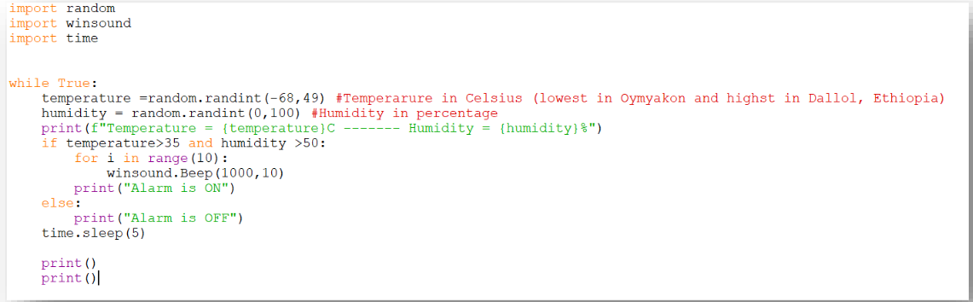

OUTPUT

